

**Piles Hospital Coimbatore - Yazh Healthcare**

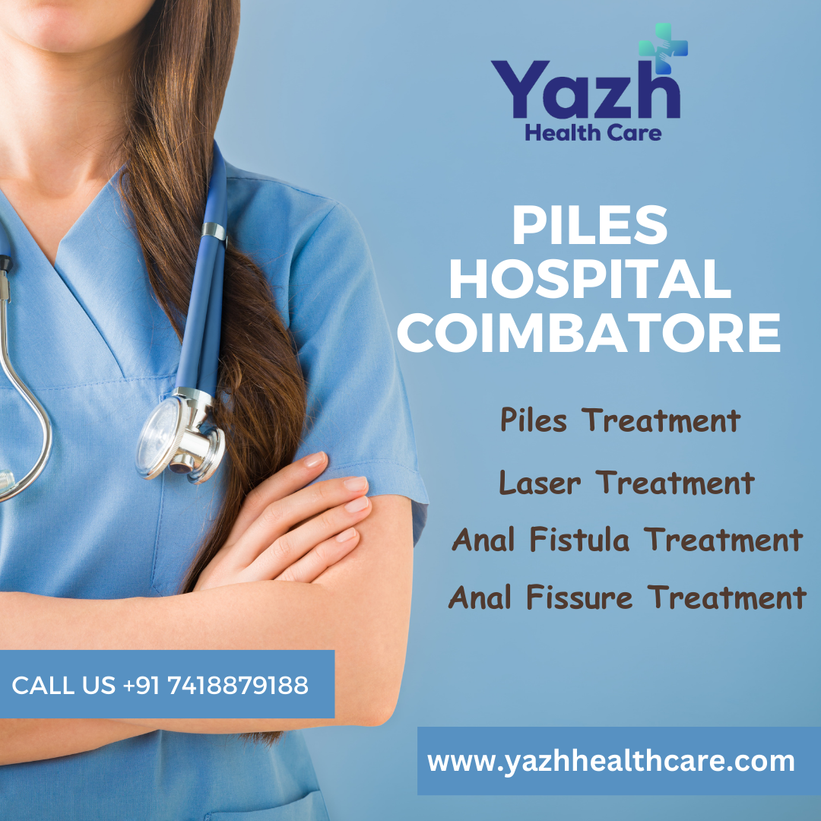

Piles, also known as hemorrhoids, affect many people and can cause discomfort, pain, and inconvenience in daily life. When looking for a trusted [**piles hospital in Coimbatore**](https://yazhhealthcare.com/piles-hospital-coimbatore/), Yazh Healthcare stands out with its specialized treatments, compassionate care, and experienced medical team.

**Why Should I Pick Yazh Healthcare for Coimbatore's Piles Hospital?**

At Yazh Healthcare, we understand the importance of personalized treatment for piles, offering a range of options based on the severity of the condition. Here’s what makes Yazh Healthcare a top choice:

**1. Comprehensive Diagnosis and Advanced Technology**

Yazh Healthcare employs advanced diagnostic tools to assess each case thoroughly. Proper diagnosis is the first step towards effective treatment, and our facility ensures that patients receive accurate and prompt evaluations.

**2. Range of Treatment Options for Piles**

We provide various treatments, from minimally invasive procedures to more intensive options. Our piles clinic in Coimbatore offers treatments like laser therapy, rubber band ligation, and sclerotherapy, each designed to address specific needs, reduce recovery time, and enhance comfort.

**3. Experienced Team of Specialists**

The skilled medical team at Yazh Healthcare includes experts in gastroenterology and proctology, ensuring that patients receive the best possible care. Our specialists are committed to treating piles with minimal discomfort, focusing on patient education and support throughout the treatment process.

**4. Patient-Centric Approach**

We prioritize patient satisfaction and comfort. Our compassionate team provides guidance and reassurance, creating a supportive environment that makes treatment easier to undergo and discuss.

**5. Affordable Piles Treatment Coimbatore**

Understanding that affordability matters, Yazh Healthcare strives to offer effective piles treatment without compromising quality. We believe that access to quality care should be within reach for everyone, making us a preferred choice among piles hospitals in Coimbatore.

**What to Expect from a Piles Treatment at Yazh Healthcare**

Yazh Healthcare uses a step-by-step method to pile treatment. From the initial consultation to follow-up care, our medical professionals are with you every step of the way. Whether you need medication for mild symptoms or minimally invasive surgery for more severe cases, Yazh Healthcare provides an individualized treatment plan to ensure optimal results.

**Yazh Healthcare: Your Reliable Piles Clinic in Coimbatore**

With a dedicated piles clinic in Coimbatore, [**Yazh Healthcare**](https://yazhhealthcare.com/) has built a reputation for excellence in piles treatment. Our hospital not only treats the symptoms but also focuses on preventive care, dietary guidance, and lifestyle recommendations to help manage and prevent the recurrence of piles.

When it comes to finding the best [**piles hospital in Coimbatore**](https://yazhhealthcare.com/piles-hospital-coimbatore/), Yazh Healthcare is committed to delivering exceptional care. If you’re struggling with piles, don’t wait to seek help—visit Yazh Healthcare, a trusted piles clinic in Coimbatore, for compassionate, effective, and affordable treatment.

For more information on our services, call Yazh Healthcare today and take the first step toward recovery.

**Contact Us:**

**Website:** <https://yazhhealthcare.com/>

**Piles Hospital Coimbatore**: https://yazhhealthcare.com/piles-hospital-coimbatore/

**Call Us:** +91 7418879188