What are the Common Mistakes to Avoid When Drafting a Legal Notice?

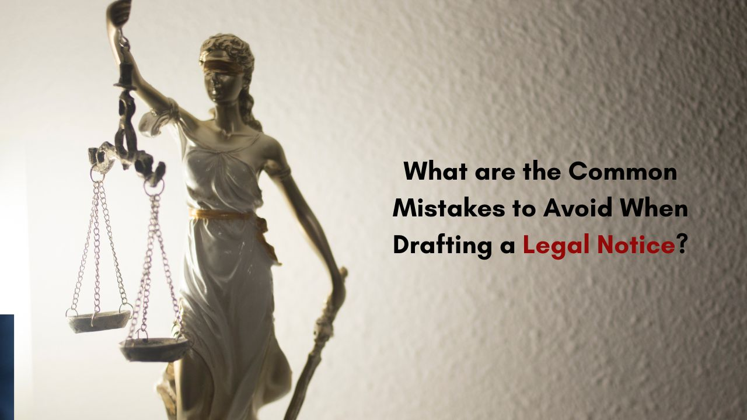

Introduction
Drafting a legal notice is a crucial step in many legal processes. It serves as a formal declaration of grievances, providing the recipient with a chance to resolve the matter before escalation. A well-prepared legal notice can protect one’s rights, but a poorly drafted one can hinder resolution and weaken a case. Here are common mistakes to avoid when drafting a legal notice, ensuring that it remains clear, concise, and legally effective.
Failing to Clearly State the Purpose of the Legal Notice
One of the primary mistakes individuals make when drafting a legal notice is failing to specify the purpose. The legal notice should explicitly convey the issue at hand, be it a cheque bounce case or a non-payment of salary. For instance, in cases involving a cheque bounce, the notice must specify that it pertains to the cheque dishonor, and mention the cheque bounce case procedure and the cheque bounce case time limit as per legal requirements. A clear and direct purpose helps the recipient understand the severity of the matter and encourages a timely response.
Not Mentioning the Types of Legal Notice
Legal notices are not a one-size-fits-all document; different types of legal notices serve different purposes. Failing to recognize this distinction may result in an improperly drafted notice that does not suit the specific case. Common types of legal notice include those for non-payment of salary, sexual harassment at the workplace, and issues related to cheque bounce. By identifying and using the appropriate format and tone for the notice type, you increase the chances of the recipient addressing the issue in a legally compliant manner.
Omitting Key Details in a Cheque Bounce Notice
A Cheque Bounce Notice requires certain specific information to comply with legal standards. This includes details such as the cheque amount, cheque number, date of issuance, and reasons for the cheque bounce. Additionally, it’s essential to outline the cheque bounce case time limit, which usually requires that the notice be sent within 30 days of the cheque bounce. Missing these essential details could weaken the notice and, in some cases, render it invalid. Each element strengthens the notice and ensures it aligns with legal requirements.
Not Outlining the Non-Payment of Salary Issue Adequately
A legal notice for non-payment of salary must be carefully structured to reflect the exact claims regarding unpaid wages. Often, individuals may omit key details such as the specific period for which the salary is due or fail to include relevant evidence, like employment agreements. It’s essential to state the total amount of unpaid salary and any additional compensation if required. By including these details, the employer is informed of the exact grievances and the desired resolution.
Ignoring Specifics in Sexual Harassment Complaints
In cases of sexual harassment at the workplace, the notice must be detailed to ensure that the allegations are taken seriously and understood thoroughly. The sexual harassment complaint process is sensitive, and the legal notice must address the issue respectfully while specifying the nature of the harassment and the parties involved. Omitting this information or being vague can diminish the gravity of the complaint. It’s essential to ensure that all details, including dates and names, are clearly stated to provide an accurate account of the incident.
Poor Structuring and Lack of Clarity
A well-structured legal notice has a logical flow that clearly outlines the grievances, supporting evidence, and expected resolution. Many notices suffer from poor organization, making it challenging for the recipient to understand the exact issue. This includes having scattered paragraphs, lack of clear sub-sections, and using complex language. An organized structure, using simple and direct language, makes the notice easier to read and comprehend. Ensure that each section – from the issue description to the resolution request – is well-defined, enhancing the overall clarity.

Using Aggressive or Threatening Language
Using confrontational or hostile language in a legal notice can backfire. While the notice should be firm, it must remain professional and respectful. Aggressive wording may provoke a negative reaction and hinder negotiation. For instance, in a cheque bounce case or a non-payment of salary dispute, maintaining a respectful tone increases the likelihood of cooperation from the other party. Instead of making demands, frame the notice in a way that seeks resolution while highlighting the consequences if the issue isn’t addressed.
Ignoring the Legal Framework and Procedures
Each type of legal notice is governed by specific laws and timelines. Failing to comply with these can render a notice ineffective. For instance, a Cheque Bounce Notice must adhere to the cheque bounce case time limit, and skipping this step could dismiss the claim entirely. Similarly, the sexual harassment complaint process has set regulations regarding workplace policies. Ignoring these procedural requirements not only weakens the notice but may also delay or dismiss the case. Staying informed about the legal framework relevant to the case ensures that the notice is both legitimate and enforceable.
Forgetting to Attach Relevant Documentation
Supporting documents are vital to a legal notice. Whether it’s a contract, receipts, or written agreements, missing these can compromise the notice’s credibility. In a non-payment of salary issue, attaching employment agreements or previous salary slips validates the claim. In the case of a cheque bounce, including a copy of the bounced cheque strengthens the claim. Proper documentation solidifies the notice and leaves no room for the other party to dispute the facts.
Not Specifying the Relief or Resolution Expected
A crucial part of any legal notice is the relief or remedy sought. Without a clear statement of the desired outcome, the notice may seem ambiguous, weakening its impact. Specify what action or compensation is required from the recipient. For example, in a legal notice for non-payment of salary, explicitly state the amount due and any additional compensation expected. By clarifying the relief sought, the recipient has a clear understanding of the actions required to settle the dispute amicably.
Overlooking the Importance of the Legal Notice Format
A legal notice must be in a formal format that aligns with legal standards. A common error is drafting the notice too informally, which reduces its effectiveness. The structure should include sections such as the sender’s details, the recipient’s details, a subject line, and the body with details of the grievance. Adhering to a professional format conveys the seriousness of the issue, making the recipient more likely to consider the notice.
Not Consulting a Legal Professional
Though individuals can draft a legal notice on their own, overlooking the guidance of a legal professional can lead to errors. Lawyers are familiar with the nuances of different cases, such as cheque bounce or sexual harassment at workplace notices. Consulting a lawyer ensures that the notice is accurately crafted and adheres to legal standards. A professional can help avoid errors, adding credibility and strength to the document.
How to Send a Legal Notice Correctly
After drafting, the next critical step is understanding how to send a legal notice. Many overlook the importance of sending the notice through the correct channels. Typically, a legal notice is sent via registered post or courier to ensure proof of dispatch and receipt. This is especially crucial in cases like cheque bounce where proof of notice delivery is required by law. Using appropriate channels not only provides evidence but also emphasizes the sender’s commitment to resolving the matter legally.
Avoiding Ambiguities in the Notice
Ambiguity in a legal notice can confuse and weaken its impact. Statements must be clear, direct, and free of vague language. For example, in cases of non-payment of salary, specifying the amount owed and the timeframe is essential. Similarly, a sexual harassment complaint should avoid generalities and instead describe specific incidents. Clear, unambiguous language ensures the recipient fully understands the grievances and is more likely to respond constructively.
Conclusion
Drafting an effective legal notice requires clarity, precision, and adherence to legal standards. Avoiding these common mistakes ensures that the notice is impactful and can potentially lead to a swift resolution. From specifying the purpose to including necessary documentation, each aspect is vital in enhancing the notice’s effectiveness. Consulting with a legal professional when in doubt can further strengthen the document, ensuring that it is prepared with legal rigor. By taking these steps, one can ensure that their legal notice upholds their rights and encourages a constructive response from the recipient.
Connect with CorpBiz Legal Advisors www.corpbiz.io or at +91-9121230280.

